**Vid 57 – Basic Threading**

T1 thread prepared when invoked to launch printA

T2 thread prepared to launch printAny w/ the argument 789

**Vid 59 – Assignment 1: Test Miner Using Threads**

* We want to create a wallet that contains a client that creates transactions at the request of probably a user
* Those transactions get received by a server which forms a list of transactions
* Then those are built into a block, and we mine it for a nonce that satisfies the requirements
* Next, we have client that sends those new blocks, any block that now has a valid nonce gets sent to a server on the wallet side. That server on the wallet side receives these blocks and puts them in a blockchain.

Client 🡪 2 Jobs

1. Create and send transactions
2. Query the balances in the blockchain

EX: if want to know # of coins you have & client will tell you by reading the block

Looking back at what happened last time and how we can improve our testing with threading

**Vid 60 – Assignment 1 Solution**

Trying to get the minerServer and nonceFinder to run at the same time

Can do something like a loop here (1:23)

One issue were gonna have is that this nonce finding is going to take a long time

**Vid 61 – Assignment 2: Wallet Client and Server**

13:54 🡪 good spot for comparing professor’s miner and wallet code

**Different Outputs when using if verbose**

**Vid 64 – Assignment 64: Saving and Restoring Keys**

<https://cryptography.io/en/latest/hazmat/primitives/asymmetric/rsa/#generation>

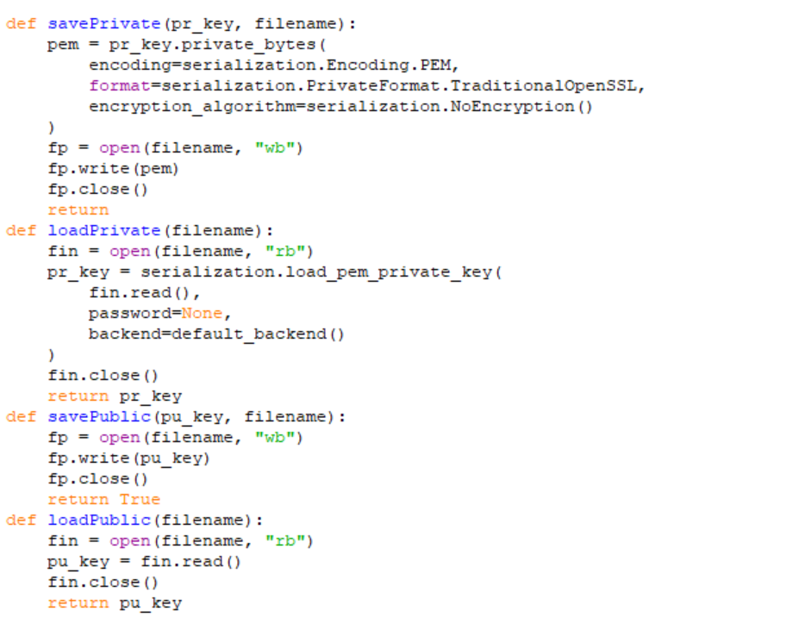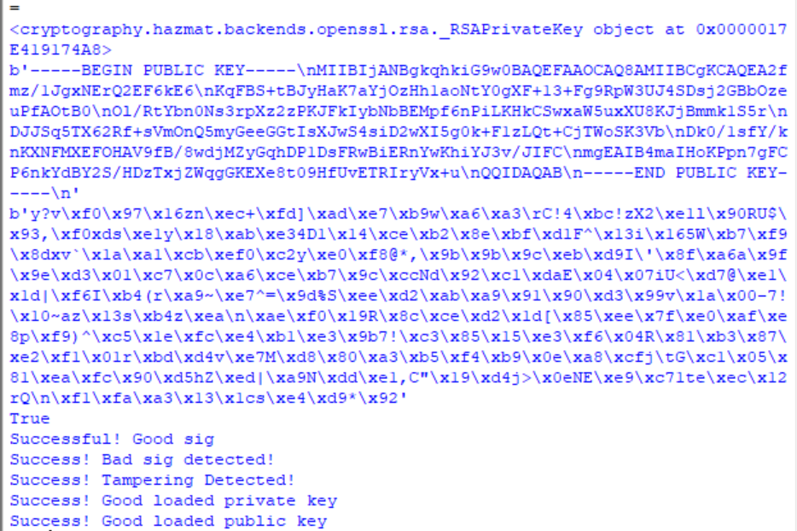

**Vid 66 – Save and Restore Blocks and Transactions**